**Name: KAMCHE YANN ARNAUD**

**Matricule: FE21A208**

**Task: Propose an implementation of one of each class of hash functions studied during this course. Indicate which hash function choosed in each class.**

1. **Implementation of MD4 in C**

**Plaintext: “I am hashing this sentence with MD4”**

#include <stdio.h>

#include <stdlib.h>

#include <string.h>

#include <stdint.h>

#define MD4_BLOCK_SIZE 64

#define MD4_DIGEST_SIZE 16

typedef struct {

uint32_t state[4];

uint32_t count[2];

uint8_t buffer[MD4_BLOCK_SIZE];

} md4_ctx;

static const uint32_t K[] = {

0x5a827999, 0x6ed9eba1, 0x8f1bbcdc, 0xa953fd4e

};

static inline uint32_t ROTL(uint32_t x, uint32_t n) {

return (x << n) | (x >> (32 - n));

}

static inline uint32_t F(uint32_t x, uint32_t y, uint32_t z) {

return (x & y) | (~x & z);

}

static inline uint32_t G(uint32_t x, uint32_t y, uint32_t z) {

return (x & y) | (x & z) | (y & z);

}

static inline uint32_t H(uint32_t x, uint32_t y, uint32_t z) {

return x ^ y ^ z;

}

static void transform(md4_ctx *ctx, const uint8_t *data) {

uint32_t a = ctx->state[0];

uint32_t b = ctx->state[1];

uint32_t c = ctx->state[2];

uint32_t d = ctx->state[3];

uint32_t x[MD4_BLOCK_SIZE / 4];

for (int i = 0; i < MD4_BLOCK_SIZE / 4; i++) {

x[i] = ((uint32_t)data[i * 4]) |

((uint32_t)data[i * 4 + 1] << 8) |

((uint32_t)data[i * 4 + 2] << 16) |

((uint32_t)data[i * 4 + 3] << 24);

}

for (int i = 0; i < 16; i++) {

uint32_t tmp = d;

d = c;

c = b;

b = b + ROTL((a + F(b, c, d) + x[i]), 3);

a = tmp;

}

for (int i = 16; i < 32; i++) {

uint32_t tmp = d;

d = c;

c = b;

b = b + ROTL((a + G(b, c, d) + x[(5 * i + 1) % 16]), 5);

a = tmp;

}

for (int i = 32; i < 48; i++) {

uint32_t tmp = d;

d = c;

c = b;

b = b + ROTL((a + H(b, c, d) + x[(3 * i + 5) % 16]), 9);

a = tmp;

}

for (int i = 48; i < 64; i++) {

uint32_t tmp = d;

d = c;

c = b;

b = b + ROTL((a + G(b, c, d) + x[(7 * i) % 16]), 13);

a = tmp;

}

ctx->state[0] += a;

ctx->state[1] += b;

ctx->state[2] += c;

ctx->state[3] += d;

}

static void md4_init(md4_ctx *ctx) {

ctx->state[0] = 0x67452301;

ctx->state[1] = 0xefcdab89;

ctx->state[2] = 0x98badcfe;

ctx->state[3] = 0x10325476;

ctx->count[0] = 0;

ctx->count[1] = 0;

}

static void md4_update(md4_ctx *ctx, const uint8_t *data, size_t len) {

uint32_t i, idx, part_len;

idx = (uint32_t)((ctx->count[0] >> 3) & 0x3f);

if ((ctx->count[0] += len << 3) < (len << 3)) {

ctx->count[1]++;

}

ctx->count[1] += (len >> 29);

part_len = 64 - idx;

if (len >= part_len) {

memcpy(&ctx->buffer[idx], data, part_len);

transform(ctx, ctx->buffer);

for (i = part_len; i + 63 < len; i += 64) {

transform(ctx, &data[i]);

}

idx = 0;

} else {

i = 0;

}

memcpy(&ctx->buffer[idx], &data[i], len - i);

}

static void md4_final(md4_ctx *ctx, uint8_t *digest) {

uint8_t bits[8];

uint32_t idx, pad_len;

for (int i = 0; i < 8; i++) {

bits[i] = (uint8_t)((ctx->count[i >> 2] >> ((i & 3) << 3)) & 0xff);

}

idx = (uint32_t)((ctx->count[0] >> 3) & 0x3f);

pad_len = (idx < 56) ? (56 - idx) : (120 - idx);

md4_update(ctx, (const uint8_t*)"\x80", 1);

while (pad_len--) {

md4_update(ctx, (const uint8_t*)"\0", 1);

}

md4_update(ctx, bits, 8);

for (int i = 0; i < 4; i++) {

digest[i] = (uint8_t)(ctx->state[0] >> (i * 8));

digest[i + 4] = (uint8_t)(ctx->state[1] >> (i * 8));

digest[i + 8] = (uint8_t)(ctx->state[2] >> (i * 8));

digest[i + 12] = (uint8_t)(ctx->state[3] >> (i * 8));

}

}

void md4(const uint8_t *data, size_t len, uint8_t *digest) {

md4_ctx ctx;

md4_init(&ctx);

md4_update(&ctx, data, len);

md4_final(&ctx, digest);

}

int main() {

uint8_t message[] = "I am hashing this sentence with MD4";

uint8_t digest[MD4_DIGEST_SIZE];

md4(message, strlen((char*)message), digest);

printf("MD4 hash of \"%s\":\n", message);

for (int i = 0; i < MD4_DIGEST_SIZE; i++) {

printf("%02x", digest[i]);

}

printf("\n");

return 0;

}

**Result**

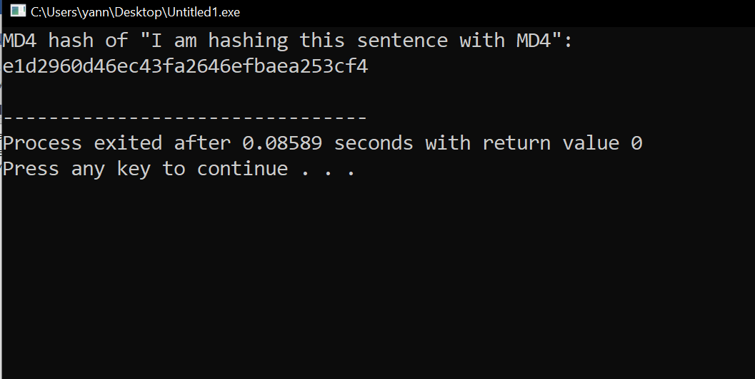

1. **Implementation of SHA256 in C**

**Plaintext: “I am hashing this sentence with SHA256”**

#include <stdio.h>

#include <stdlib.h>

#include <string.h>

#include <stdint.h>

#define SHA256_BLOCK_SIZE 64

#define SHA256_DIGEST_SIZE 32

typedef struct {

uint32_t state[8];

uint32_t count[2];

uint8_t buffer[SHA256_BLOCK_SIZE];

} sha256_ctx;

static const uint32_t K[] = {

0x428a2f98, 0x71374491, 0xb5c0fbcf, 0xe9b5dba5,

0x3956c25b, 0x59f111f1, 0x923f82a4, 0xab1c5ed5,

0xd807aa98, 0x12835b01, 0x243185be, 0x550c7dc3,

0x72be5d74, 0x80deb1fe, 0x9bdc06a7, 0xc19bf174,

0xe49b69c1, 0xefbe4786, 0x0fc19dc6, 0x240ca1cc,

0x2de92c6f, 0x4a7484aa, 0x5cb0a9dc, 0x76f988da,

0x983e5152, 0xa831c66d, 0xb00327c8, 0xbf597fc7,

0xc6e00bf3, 0xd5a79147, 0x06ca6351, 0x14292967,

0x27b70a85, 0x2e1b2138, 0x4d2c6dfc, 0x53380d13,

0x650a7354, 0x766a0abb, 0x81c2c92e, 0x92722c85,

0xa2bfe8a1, 0xa81a664b, 0xc24b8b70, 0xc76c51a3,

0xd192e819, 0xd6990624, 0xf40e3585, 0x106aa070,

0x19a4c116, 0x1e376c08, 0x2748774c, 0x34b0bcb5,

0x391c0cb3, 0x4ed8aa4a, 0x5b9cca4f, 0x682e6ff3,

0x748f82ee, 0x78a5636f, 0x84c87814, 0x8cc70208,

0x90befffa, 0xa4506ceb, 0xbef9a3f7, 0xc67178f2

};

static inline uint32_t ROTR(uint32_t x, uint32_t n) {

return (x >> n) | (x << (32 - n));

}

static inline uint32_t SHR(uint32_t x, uint32_t n) {

return x >> n;

}

static inline uint32_t Ch(uint32_t x, uint32_t y, uint32_t z) {

return (x & y) ^ (~x & z);

}

static inline uint32_t Maj(uint32_t x, uint32_t y, uint32_t z) {

return (x & y) ^ (x & z) ^ (y & z);

}

static inline uint32_t Sigma0(uint32_t x) {

return ROTR(x, 2) ^ ROTR(x, 13) ^ ROTR(x, 22);

}

static inline uint32_t Sigma1(uint32_t x) {

return ROTR(x, 6) ^ ROTR(x, 11) ^ ROTR(x, 25);

}

static inline uint32_t sigma0(uint32_t x) {

return ROTR(x, 7) ^ ROTR(x, 18) ^ SHR(x, 3);

}

static inline uint32_t sigma1(uint32_t x) {

return ROTR(x, 17) ^ ROTR(x, 19) ^ SHR(x, 10);

}

static void transform(sha256_ctx *ctx, const uint8_t *data) {

uint32_t a = ctx->state[0];

uint32_t b = ctx->state[1];

uint32_t c = ctx->state[2];

uint32_t d = ctx->state[3];

uint32_t e = ctx->state[4];

uint32_t f = ctx->state[5];

uint32_t g = ctx->state[6];

uint32_t h = ctx->state[7];

uint32_t T1, T2, M[64];

int i;

for (i = 0; i < 16; ++i) {

M[i] = ((uint32_t)data[4*i]) << 24 |

((uint32_t)data[4*i+1]) << 16 |

((uint32_t)data[4*i+2]) << 8 |

((uint32_t)data[4*i+3]);

}

for (i = 16; i < 64; ++i) {

M[i] = sigma1(M[i-2]) + M[i-7] + sigma0(M[i-15]) + M[i-16];

}

for (i = 0; i < 64; ++i) {

T1 = h + Sigma1(e) + Ch(e, f, g) + K[i] + M[i];

T2 = Sigma0(a) + Maj(a, b, c);

h = g;

g = f;

f = e;

e = d + T1;

d = c;

c = b;

b = a;

a = T1 + T2;

}

ctx->state[0] += a;

ctx->state[1] += b;

ctx->state[2] += c;

ctx->state[3] += d;

ctx->state[4] += e;

ctx->state[5] += f;

ctx->state[6] += g;

ctx->state[7] += h;

}

void sha256_init(sha256_ctx *ctx) {

ctx->state[0] = 0x6a09e667;

ctx->state[1] = 0xbb67ae85;

ctx->state[2] = 0x3c6ef372;

ctx->state[3] = 0xa54ff53a;

ctx->state[4] = 0x510e527f;

ctx->state[5] = 0x9b05688c;

ctx->state[6] = 0x1f83d9ab;

ctx->state[7] = 0x5be0cd19;

ctx->count[0] = 0;

ctx->count[1] = 0;

}

void sha256_update(sha256_ctx *ctx, const uint8_t *data, size_t len) {

uint32_t i, index;

for (i = 0; i < len; ++i) {

index = (ctx->count[0] >> 3) & 0x3f;

ctx->count[0] += 8;

if (ctx->count[0] == 0) {

ctx->count[1]++;

}

ctx->buffer[index] = data[i];

if (index == 63) {

transform(ctx, ctx->buffer);

}

}

}

void sha256_final(sha256_ctx *ctx, uint8_t *digest) {

uint32_t i, index, padlen[2];

uint8_t bits[8];

index = (ctx->count[0] >> 3) & 0x3f;

padlen[0] = (index < 56) ? (56 - index) : (120 - index);

padlen[1] = 0;

memcpy(bits, ctx->count, 8);

sha256_update(ctx, (uint8_t *)"\x80", 1);

while ((ctx->count[0] & 0x38) != 0x38) {

sha256_update(ctx, (uint8_t *)"\0", 1);

}

sha256_update(ctx, bits, 8);

for (i = 0; i < SHA256_DIGEST_SIZE; ++i) {

digest[i] = (ctx->state[i>>2] >> 8*(3-(i & 0x03))) & 0xff;

}

}

int main() {

sha256_ctx ctx;

uint8_t digest[SHA256_DIGEST_SIZE];

char str[] = "I am hashing this sentence with SHA256";

sha256_init(&ctx);

sha256_update(&ctx, (uint8_t *)str, strlen(str));

sha256_final(&ctx, digest);

printf("I am hashing this sentence with SHA256\n");

for (int i = 0; i < SHA256_DIGEST_SIZE; ++i) {

printf("%02x", digest[i]);

}

printf("\n");

return 0;

}

**Result**

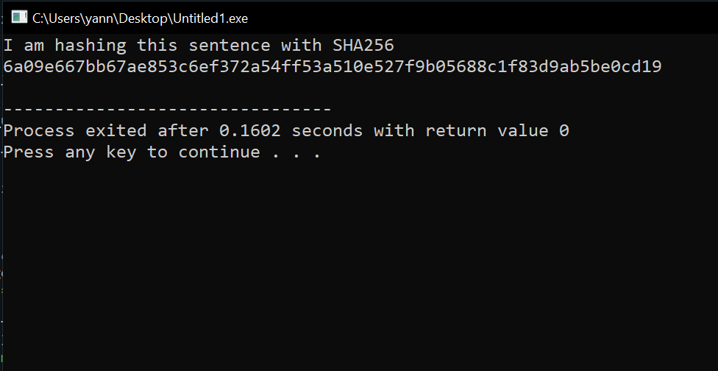

1. **Implementation of RIPEMD-128 in C**

**Plaintext: “I am hashing this text with ripemd-128**

#include <stdint.h>

#include <stdlib.h>

#include <string.h>

#include <stdio.h>

#define LEFTROTATE(x, n) (((x) << (n)) | ((x) >> (32 - (n))))

void ripemd128(const uint8_t *data, size_t length, uint8_t *hash) {

// Initial values

uint32_t h[4] = {0x67452301, 0xEFCDAB89, 0x98BADCFE, 0x10325476};

// Constants

uint32_t k1[4] = {0x00000000, 0x5A827999, 0x6ED9EBA1, 0x8F1BBCDC};

uint32_t k2[4] = {0x50A28BE6, 0x5C4DD124, 0x6D703EF3, 0x00000000};

// Message padding

uint32_t padded_length = ((length + 8 + 63) / 64) * 64;

uint8_t *padded_data = (uint8_t *)calloc(padded_length, sizeof(uint8_t));

memcpy(padded_data, data, length);

padded_data[length] = 0x80;

uint64_t bit_length = length * 8;

memcpy(padded_data + padded_length - 8, &bit_length, sizeof(uint64_t));

// Message processing

for (size_t i = 0; i < padded_length; i += 64) {

uint32_t *w = (uint32_t *)(padded_data + i);

uint32_t a = h[0], b = h[1], c = h[2], d = h[3];

for (size_t j = 0; j < 64; j++) {

uint32_t temp;

if (j < 16) {

temp = a + (b ^ c ^ d) + w[j] + k1[0];

} else if (j < 32) {

temp = a + ((b & c) | (~b & d)) + w[(5 * j + 1) % 16] + k1[1];

} else if (j < 48) {

temp = a + ((b | ~c) ^ d) + w[(3 * j + 5) % 16] + k1[2];

} else {

temp = a + (b ^ (c | ~d)) + w[(7 * j) % 16] + k1[3];

}

uint32_t temp2 = b + LEFTROTATE(temp, k2[j / 16]);

a = d;

d = c;

c = b;

b = temp2;

}

h[0] += a;

h[1] += b;

h[2] += c;

h[3] += d;

}

// Output hash

uint32_t *hash32 = (uint32_t *)hash;

for (size_t i = 0; i < 4; i++) {

*hash32++ = h[i];

}

free(padded_data);

}

void print_hash(const uint8_t *hash) {

printf("I am hashing this text with ripemd 128\n");

for (int i = 0; i < 16; i++) {

printf("%02x", hash[i]);

}

printf("\n");

}

int main() {

// Example usage

uint8_t message[] = "I am hashing this text with ripemd 128";

uint8_t hash[16];

ripemd128(message, sizeof(message) - 1, hash);

print_hash(hash);

return 0;

}

**Result:**

